# Chapter 1: The ABC of Programming

-A script is a series of instructions that a computer can follow to achieve a goal.

-To write a script, you need to 1st state your goal and then list the tasks that need to be completed in order to achieve it:  
+Define the goal.

+Design the script.

+Code each step.

-Designing a script: tasks: The high-level view of tasks can be presented using a flowchart.

-Designing a script: steps: When you ready to code the script, steps can then be translated into lines of code.

-The document object represents an HTML page. Using document object, we can access and change what content users see on page and respond. Like other objects, document has: properties + methods + events

-How a browser sees a web page

+The browser receives an HTML page

+It creates a model of page and store it in memory.

+It shows the page on screen using a rendering engine (may use CSS)

-How HTML, CSS & JavaScript fit together

+HTML (Content Layer): give the page structure and adds semantics

+CSS (Presentation Layer): enhances the HTML page with rules that state how HTML content is presented

+JS (Behavior Layer): where we change how the page behaves, adding interactivity.

-Progressive enhancement: 3 layers form the basis of this popular approach to building web page: Start with HTML, then add CSS rules, JS is added last.

-Sample code: www.javascriptbook.com

-Creating a basic JS:

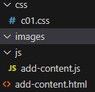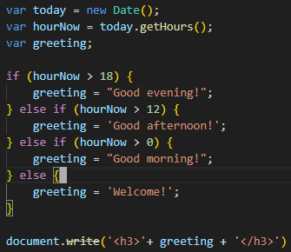

-Linking to a JS file from HTML page: Use <script src>  
-Placing the script in the page:

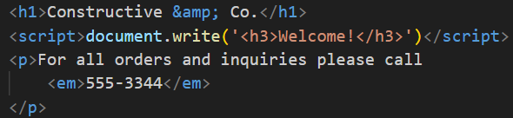

-JS runs where it is found in the HTML: When browser comes across a <script>, it stops to load the script and then checks to see if it needs to do anything.

# Chapter 2: Basic JavaScript Instructions

-Statements: each individual instruction or step, should end with a semicolon.

-Comment: //, /* */

-Variable: store data

-Variables: how to declare them

+variable keyword + variable name: var quantity;

-Varibles: how to assign them a value

+variable name + assignment operator + variable value: quantity = 3;

-Data types

+Numeric data type

+String data types: can be single or double quotes

+Boolean data type

-Using a variable to store a number

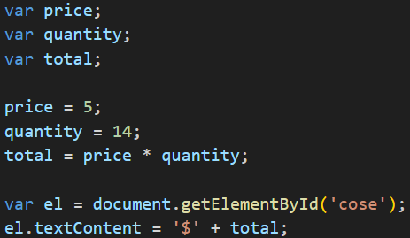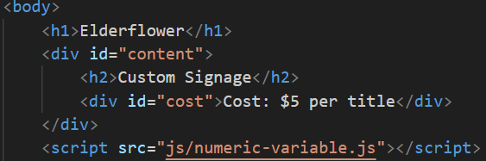

-Using a variable to store a string

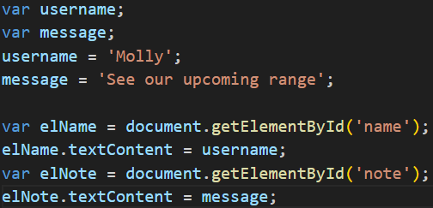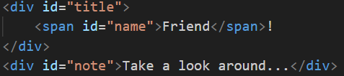

-Using quotes inside a string

+” ‘’ ” or ‘ “ “ ’

+Escaping the quotation characters: use backward slash before any type of quote mark that appears with a string ->the following character is part of string.

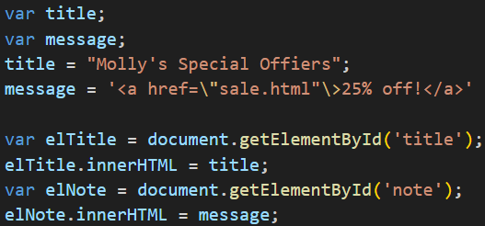

-Using a variable to store a Boolean

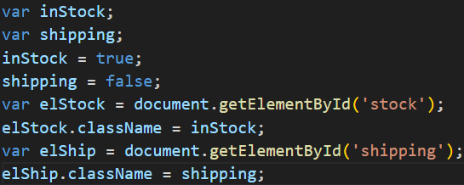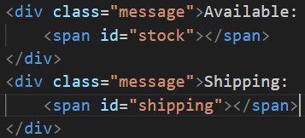

+The value are used in class attributes of HTML elements. These values trigger CSS class rules: true show a check, false show a cross.

-Shorthand for creating variable

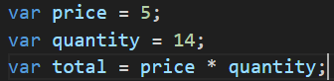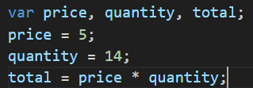

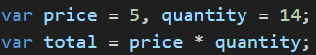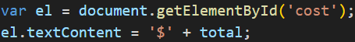

-Changing the value of a variable

-Rules for naming variable: Same in Java

-Arrays: store a list of values

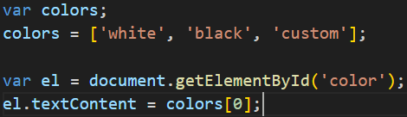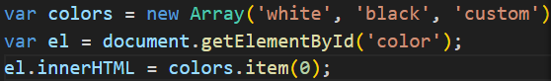

+Number of items: colors.length;

-Expressions: evaluates into a single value. There are 2:

+assign a value to a variable

+use 2 or more values to return a single value

-Operators

+Assignment

+Arithmetic operators

+String operators

+Comparison operators

+Logical operators

# Chapter 3: Functions, Methods & Objects

-Immediately invoked function expressions:

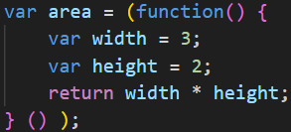

-Variable scope: local variable + global variable

-Creating object:

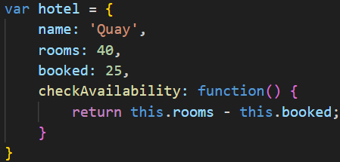

+Access object and dot notation:

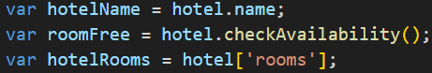

+Creating object: constructor notation

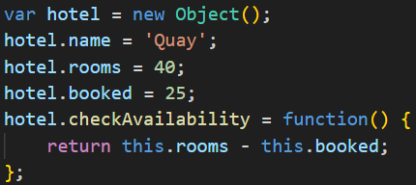

+Create many objects: constructor notation

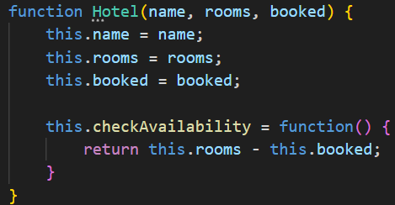

+Add and remove properties:

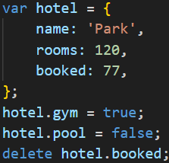

-Arrays are objects: They hold a related set of key/value pairs: costs = [420, 460, 230, 620];

-3 groups of built-in objects:

+Browser object model:

Window (current browser window or tab)-> document (current web page) + history (pages in browser history) + location (url of current page) + navigator (information about browser) + screen (device’s display information)

+Document object model:

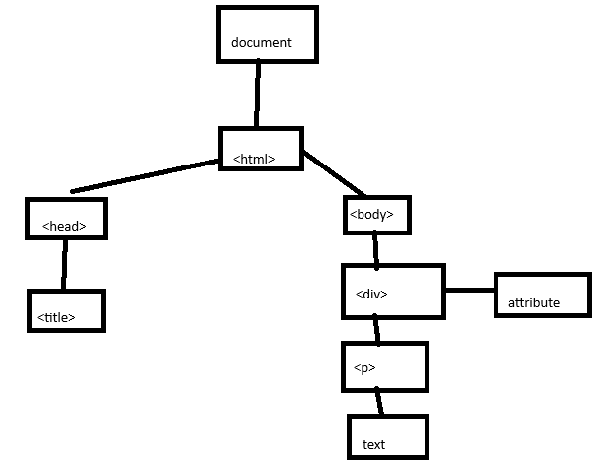

-Global JS objects:

+String: for working with string values

+Number: For working with numeric values

+Boolean: for working with Boolean values

+Date: represent and handle dates

+Math: work with numbers and calculations

+Regex: match patterns within strings of text

-Browser object model: The window object

|  |  |
| --- | --- |
| Property | Description |
| window.innerHeight | Height of window |
| window.innerWidth | Width of window |
| window.pageXOffset | Distance document has been scrolled horizontally |
| window.pageYOffset | Distance document has been scrolled vertically |
| window.screenX | X-coordinate of pointer, relative to top left corner of screen |
| window.screenY | Y-coordinate of pointer, relative to top left corner of screen |
| window.location | Current URL of window object (or local file path) |
| window.document | Reference to document object, which is used to represent the current page contained in window |
| window.history | Reference to history object for browser window or tab, which contains details of pages that have been viewed in that window or tab |
| window.history.length | Number of items in history object for browser window or tab |
| window.screen | Reference to screen object |
| window.screen.width | Access screen object and find value of its width property |
| window.screen.height | Access screen object and find value of its height property |

|  |  |
| --- | --- |
| Method | Description |
| window.alert() | Create dialog box with message (user must click OK button to close it) |
| window.open() | Open new browser window with URL specified as parameter |
| window.print() | Tell browser that user wants to print contents of current page |

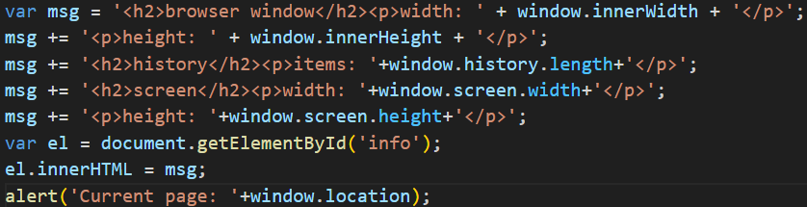

-The document object model (**DOM**): The **document** object

|  |  |
| --- | --- |
| **Property** | **Description** |
| document.title | Title of current document |
| document.lastModified | Date on which document was last modified |
| document.URL | Return string containing URL of current document |
| document.domain | Return domain of current document |

|  |  |
| --- | --- |
| **Method** | **Description** |
| document.write() | Write text to document |
| document.getElementById() | Return element, if there is an element with value of id attribute that matches |
| document.querySelectorAll() | Return list of element that match a CSS selector, which is specified as a parameter |
| document.createElement() | Create new element |
| document.createTextNode() | Create new text node |

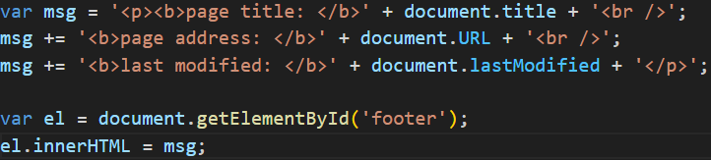

-Global objects: string object

+Property: length

+methods: toUpperCase(), toLowerCase(), charAt(), indexOf(), lastIndexOf(), subString(), split(), trim(), replace()

-Data types revisited:

+5 primitive data types: String, Number, Boolean, Undefined, Null

+Complex data type: Object, Arrays, Functions

-Global object: Number Object

|  |  |
| --- | --- |
| **Method** | **Description** |
| isNaN() | Check if the valiue is not number |
| toFixed() | Rounds to specified number of decimal places (return string) |
| toPrecision() | Rounds to total number of places (return string) |
| toExpotential() | Return string representing the number in exponential notation |

-Global objects: Math object

+Property: Math.PI

+Methods: Math.round(), Math.sqrt(), Math.ceil(), Math.floor(), Math.random()

-Global object: Date object

+var today = new Date();

+getDate()/setDate(), getDay() 0-6, getFullYear()/setFullYear(), getHours()/setHours() 0-23, getMilliseconds()/setMilliseconds() 0-999, getMinutes()/setMinutes() 0-59, getMonth()/setMonth() 0-11, getSeconds()/setSeconds() 0-59, getTime()/setTime(), getTimeZoneOffset(), toDateString(), toTimeString(), toString()

+Use format: YYYY, MM, DD, HH, MM, SS or

MMM (Mon/Tue) DD, YYYY HH:MM:SS

# Chapter 4: Decisions & Loops

-Evaluating conditions & conditional statement: if else

-Comparison operators: == != === !== > >= < <=

-Logical operators: && || !  
-Loops: for, while, do while

# Chapter 5: Document Object Model

-Document object model (**DOM**) specifies how browsers should create a model of HTML page and how JS can access and update content of web page while it is in the browser window.

-DOM is neither part of HTML or JS, it’s separate set of rules. It’s implemented by all major browser makers, ane covers 2 primary areas:

+Make a model of HTML page: When browser loads a web page, it creates a model of page in memory. DOM specifies the way in which browser should structure this model using DOM tree.

+Access and change HTML page: DOM defines methods and properties to access and update each object in this model.

-DOM is an API: user interfaces let human interact with programs, APIs let programs (and scripts) talk to each other.

-**DOM tree is a model of a web page**

+As browser loads a web page, it creates a model of page. The model is DOM tree, and it’s stored in browser’s memory. It’s consists of 4 main types of nodes

+Document node: represent the entire page

+Element nodes: relationships between document and all element nodes are: parent, children, siblings, ancestors and descendants.

+Attribute nodes: are not children of element that carries them, they are part of that element.

+Text nodes: Can’t have children, if element contains text and another child element, child element isn’t a child of text node but rather a child of containing element.

-**Working with DOM tree**

+**Step** **1**: **Access the elements**

Select an **individual element node**: getElementById() + querySelector(css selector), traverse from one element to another within DOM tree

Select **multiple elements** (nodelists): getElementsByClassName(class), getElementByTagName(tag name), querySelectorAll(css selector)

**Traverse** between element nodes: parentNode, previousSibling/nextSibling, firstChild/lastChild

+**Step 2: Work with those elements**

Access/update **text nodes**: firstChild, nodeValue

Work with **HTML content**: innerHTML, textContent, createElement(), createTextNode(), appendChild()/removeChild()

Access or update **attribute values**: className/id, hasAttribute(), getAttribute(), setAttribute(), removeAttribute()

**-Caching DOM queries**

+**DOM queries**: methods that find elements in DOM tree

+When a script select an element to access/update, then interpreter must find the element(s) in Dom tree.

+variable **doesn’t store the element**, it stores a **reference** to where that node is in DOM tree.

-**Select element** using **ID attributes**:

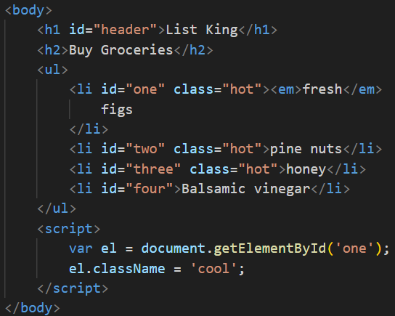

+Use a property **className** to update value of class attribute of element stored in el variable.

-**Nodelists**: DOM queries that return more than one element

+getElementsByTagName(‘h1)

+getElementsByClassName(‘hot’)

+querySelectorAll(‘li[id]’): return elements <li> having [id] attribute

-**Select** an **element** from a **nodelist**:

+**item()**

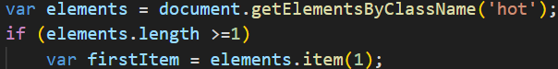

+**Array syntax**:

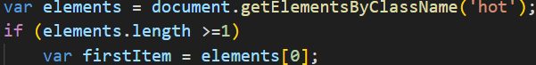

-Select elements using **class attributes**

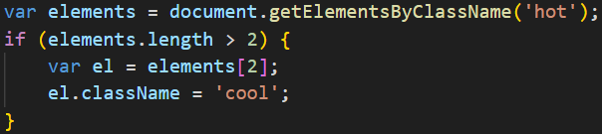

-Select elements by **tag name**

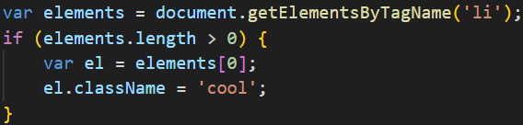

-Select elements using **CSS selectors**:

+**querySelector()**: return 1st element node that matches CSS style selector

+**querySelectorAll():** return NodeList of all matches

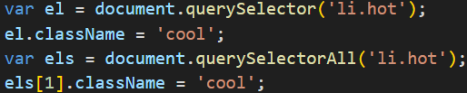

-**Repeat** actions for an entire **nodelist**:

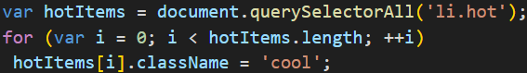

-**Traverse** the **DOM**

+**parentNode**: finds the element node for the containing element in HTML

+**previousSibling, nextSibling**

+**firstChild, lastChild**

-**whitespace nodes**: Some browsers add a text node whenever they com across whitespace between elements. So properties above return different elements in different browsers. You could **strip all whitespace** out of HTML page -> harder to read.

+One of the most popular ways to address this kind of problem is use **jQuery**.

-Previous & next sibling

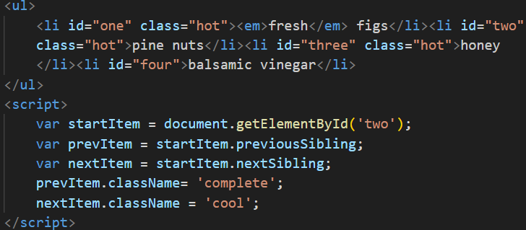

-First & last child:

+These properties also return consistent results if there is **whitespace** between elements. We can make **closing tags put next to opening tags** of next element

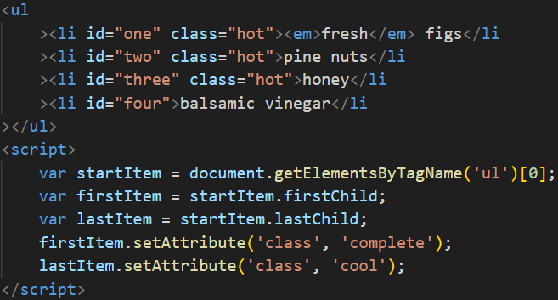

-**Get/Update** **element content**

+**Text nodes**: **nodeValue**: access text from node

+**Contain element**

|  |  |
| --- | --- |
| **Property** | **Description** |
| innerHTML | Get/set text & markup |
| textContent | Get/set text only |
| innerText | Get/set text only |

-Access & Update a text node with **nodeValue**:

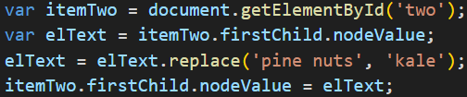

-Add or remove HTML content

+**innerHTML**: update entire fragment

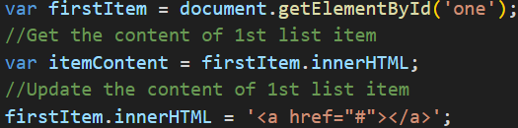

+**DOM manipulation methods**: target individual nodes in DOM tree: **createElement()**, **createTextNode()**, **appendChild()**

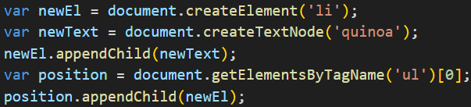

+**Remove elements via DOM manipulation**

Store element to be removed in a variable

Store parent of that element in a variable: **parentNode**

Remove element from its containing element: **removeChild()**

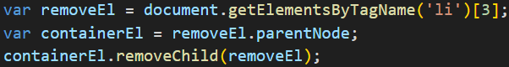

-Compare techniques: update HTML content

|  |  |  |  |
| --- | --- | --- | --- |
|  | document.write | element.innerHTML | DOM manipulation |
| Advantage | Quick and easy way to show beginners how content can be added to a page | Get/update the entire content of any element (including markup) as a string | Use a set of methods and properties to access, create, and update elements and text nodes |
| Disadvantagse | Only works when the page initially loads.  If you use if after page has loaded: overwrite the whole page, not add the content the page, create a new page  Cause problems with XHTML  Very rarely used these days | Not used to add content that has come from user (username or blog comment), it can pose a security risk.  Can be difficult to isolate single element that you want to update within a larger DOM fragment  Event handlers may no longer work as intended | Make a lot of changes to content of page, slower than innerHTML  Need to write more code to achieve the same thing compared with innerHTML |

-Cross-Site Scripting (XSS) attacks

+If you add HTML to a page using innerHTML(or jQuery methods), aware of Cross-Site Scripting Attack (XSS), an attacker could gain access to users’ account.

+How XSS happesn: XSS involves an attacker placing malicious code into a site. Websites often feature content created by many different people (Users can create profiles or add comments, Files such as images and video may by uploaded, Data can come from 3rd party sites such as Facebook, Twitter, news tickers)

+What can these attacks do: XSS can give attacker access to information in (the DOM, website’s cookie, Session token: information that identifies you from other users when you log into a site)

-Defend against XSS:

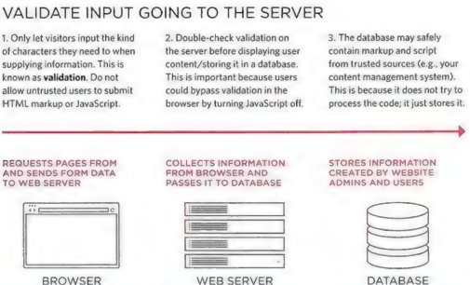

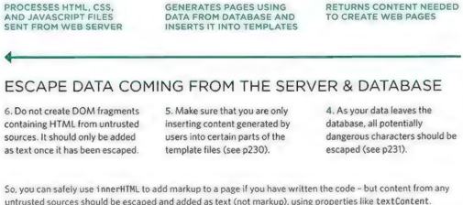

-XSS: Validation & templates

+Make sure uses can only input characters they need to use and limit where this content will be shown on page

+Filter or validate input

+Limit where user content goes

-XSS: Escaping & Controlling markup

+Escaping user content: all data from untrusted sources should be escaped on server before shown on page. Most server-side languages offer helper functions that will strip-out or escape malicious code.

HTML:

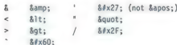

JS: Never include data from untrusted sources in JS. It involves escaping all ASCII characters.

URLS: If you have links containg user input ,use **encodeURIComponent()** to encode user input. It encodes the characters:

+Adding user content

JavaScript: use textContent or innerText, don’t use innerHTML

jQuery(): use .text(), don’t use .html()

You can still use innerHTML and .html() if: control all of markup being generated (don’t allow user content that could contain markup) + user’s content is escaped and added as text using approaches

-Attribute Nodes: Once you have element node, you can use other property and methods on that element node to access and change attributes: getAttribute(), has Attribute(), setAttribute(), removeAttribute(), className, id

-Check for an attribute and get it’s value:

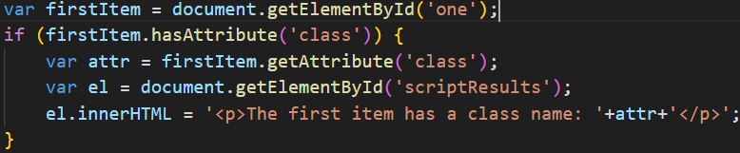

-Create attributes & change their values

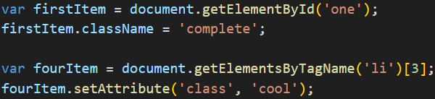

-Remove attributes

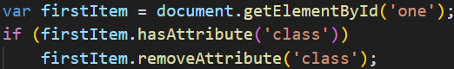

-Examine the DOM in Chrome: Inspect->Elements->Properties

# Chapter 6: Events

-**Different Event Types**

+**UI events**: Occur when user interacts with browser’s UI rather than web page:

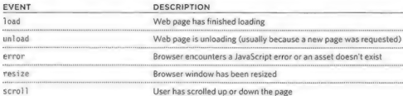

+**Keyboard events**: user interact with keyboard

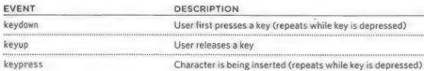

+**Mouse events**: user interacts with a mouse, trackpad, or touchscreen

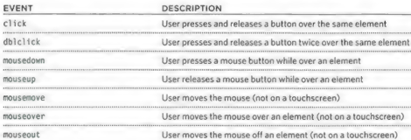

+**Focus event**: an element (link/form) gain or loses focus

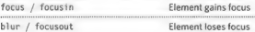

+**Form event**: user interacts with form element

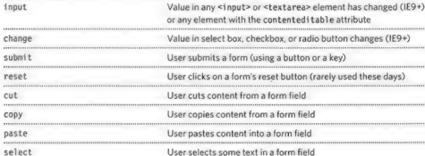

+Mutation events: DOM structure has been changed by a script (replaced by mutation observers)

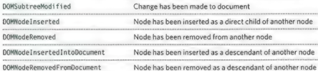

-**Terminology**

+Event fire or are raised: if user is tapping on a link, a click event would fire in browser

+Events trigger scripts: when click event fires on element, it could trigger a script that enlarges the selected item.

-How events trigger JS code:

+Select element node(s) the script respond to.

+Indicate the event on node(s)

+State the code to run when event occurs

-3 ways to bind an event to an element:

+HTML event handler attributes (DO NOT USE)  
<a> can have **onclick, onmouseover, onmouseout**

<for> have **onsubmit**

<input> have **onkeypress, onfocus, onblur**

+Traditional DOM event handlers

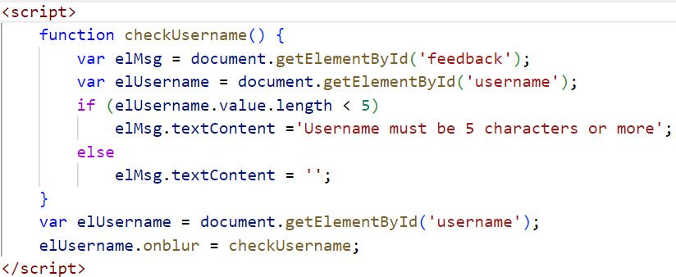

+DOM level 2 event listener: a more recent approach to handling events. They can deal with more than one function at a time.

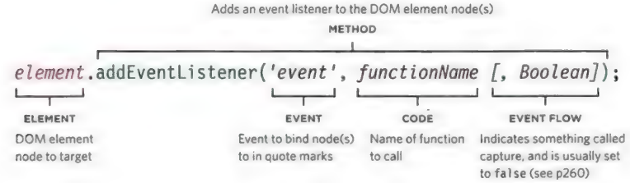

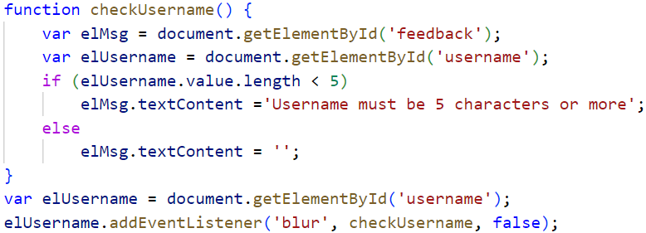

Using parameter with event listener: wrap function call in anonymous function

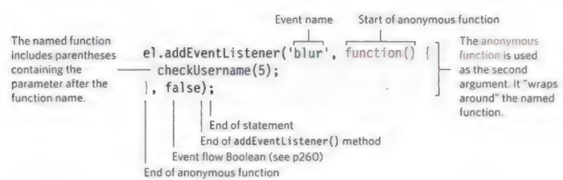

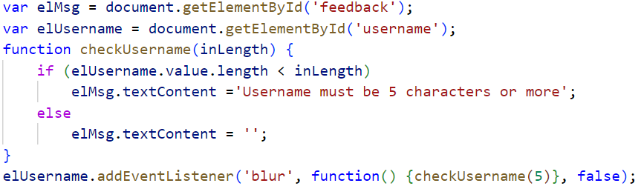

-**Event Flow**

+HTML elements nest inside other elements. If you hover or click on a link, you will also be hovering or clicking on its parent elements.

+**Event bubbling**: the event starts at the most specific node and flows outwards to the least specific one. This is the default type of event flow with very wide browser support

+**Event capturing**: The event starts at the least specific node and flows inwards to the most specific one. This is not supported in IE 8 and earlier.

-Why Flow matters

+The flow of events only really matters when code has event handlers on an element and on of its ancestor or descendant elements.

+For DOM event handlers, all modern browsers default to using event bubbling rather than capturing. With event listeners, final parameter in addEventListener() lets you choose the direction to trigger event (true=capturing phase, false = bubbling phase, often default choice)

-**Event object:** When an event occurs, the event object tells you information about the event, and the element it happened upon.

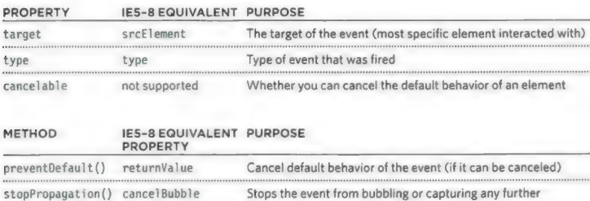

-The event object in IE5-8

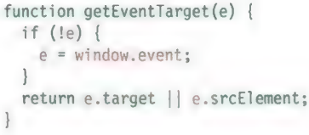

-Using event listeners with the event object

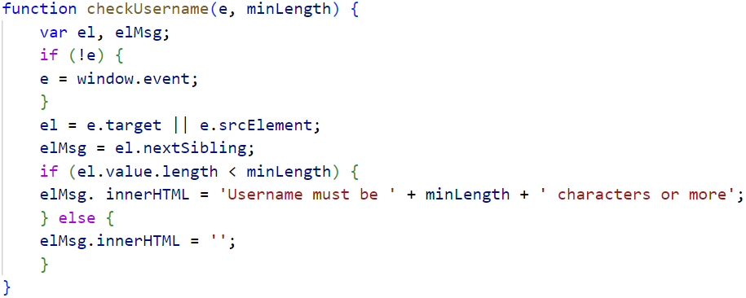

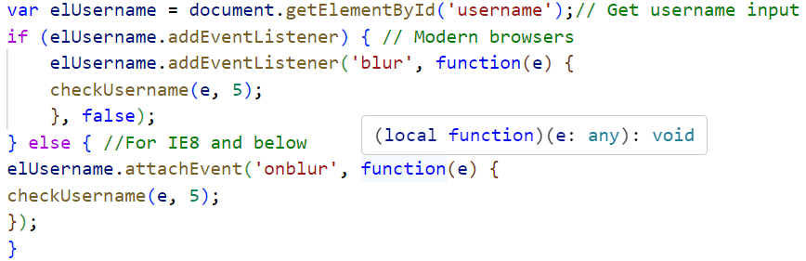

-**Event Delegation**

+If users interact with lots of elements, adding event listeners to each element can use a lot of memory and slow down performance

+You can place event handlers on containing element and use event object target to find which of its children the event happened on.

-Change default behavior:

+**preventDefault()**: prevent the default behavior of elements. IE5-8 **returnValue**

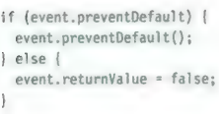

+**stopPropagation ()**: stop event bubbling up. IE8 is **cancelBubble**

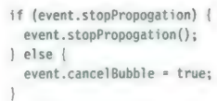

+Using both methods: prevent the default behavior of element + prevent event from bubbling up or capturing further.

-Using Event Delegation:

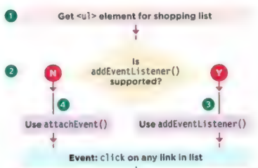

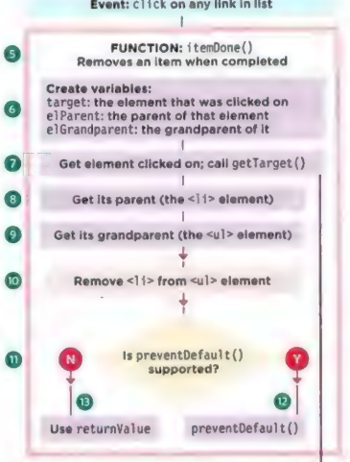

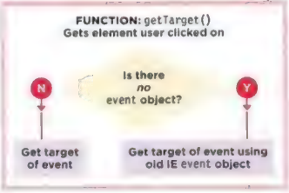

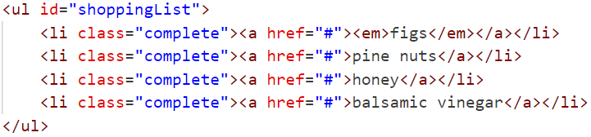

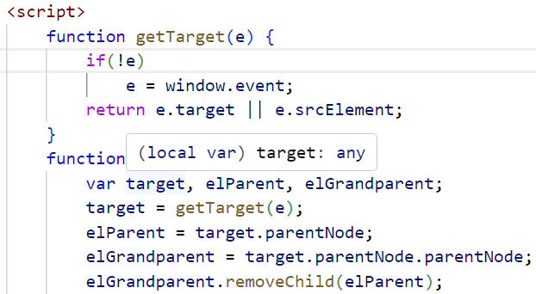

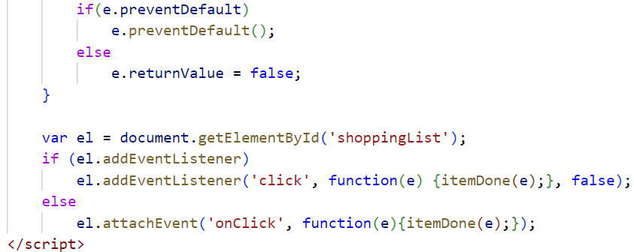

-**Different types of events**:

+**W3C DOM events**: DOM events specification managed by W3C (also look after other specifications HTML, CSS, XML). Most of events you meet are part of DOM events

+**HTML5 events**: details events that browsers are expected to support that are specifically used with HTML.

+**BOM events**: events as part of Browser Object Model.

-**User Interface events**: UI events occur as a result of interaction with the **browser window** rather than HTLM

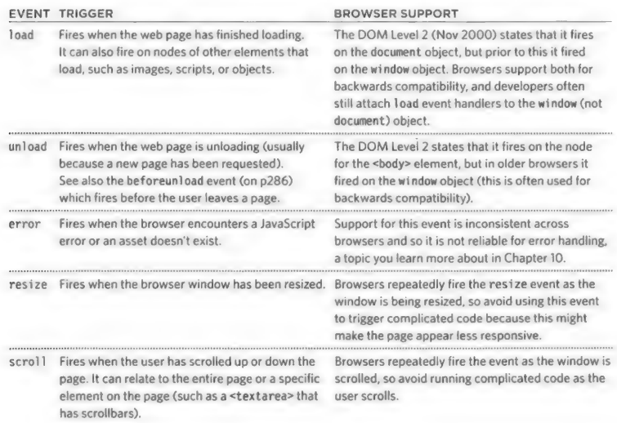

+**load**: trigger scripts that access the content of page. The event is automatically raised by window object when page finished loading HTML and all its resources

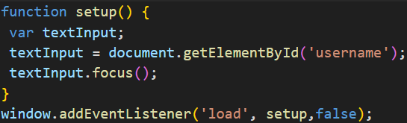

-**Focus & Blur events**: HTML elements you can interact with, such as links and form elements, can gain focus. These events fire when they gain or lose focus

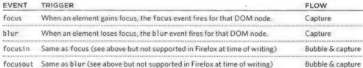

+Focus & Blur:

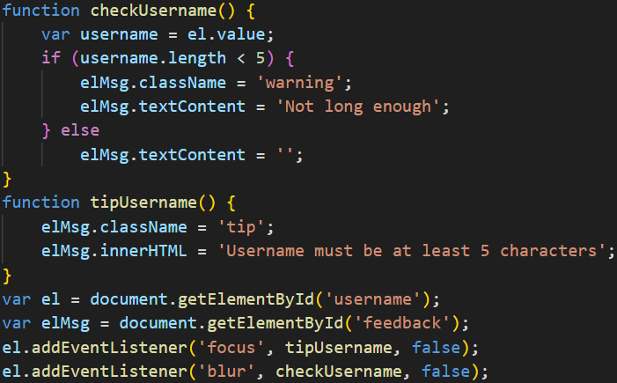

-**Mouse events**: fired when the mouse is moved and also when its buttons are clicked. All elements on page support mouse events, and all of these bubble. Prevent default behavior can have unexpected results (click only fires when both mousedown and mouseup fired)

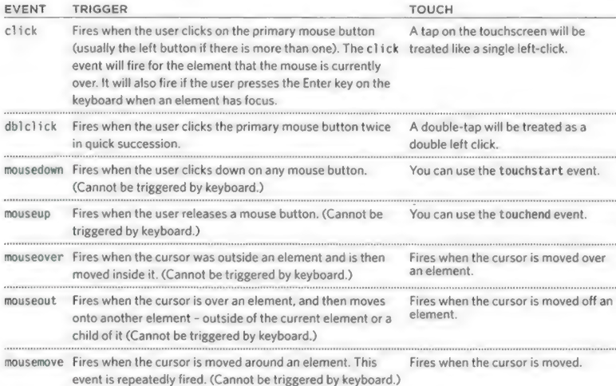

+click:

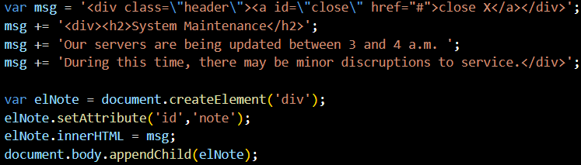



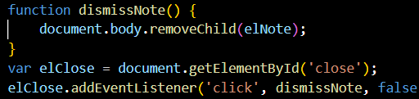

-Where events occur: event object can tell where the cursor was positioned when an event was triggered

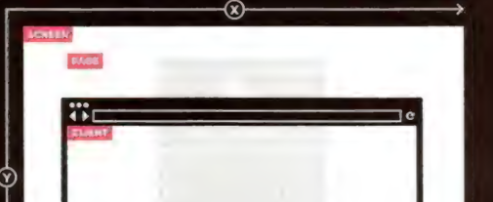

+Screen: screenX, screenY indicate the position of cursor within the entire screen on monitor.

+Page: pageX, pageY indicate the position of cursor within the entire page. The top of page may be outside of viewport so even if cursor is the same position, page and client coordinates can be different

+Client: clientX, clientY indicate the position of cursor within the browser ‘s viewport. If user has scrolled down and top of page is no longer in view, it will not affect the client coordinates.

-**Keyboard events**: fired when user interacts with keyboard (they fie on any kind of device with a keyboard)

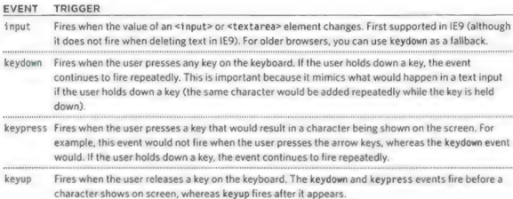

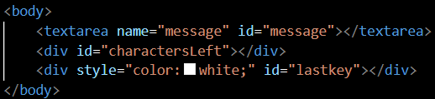

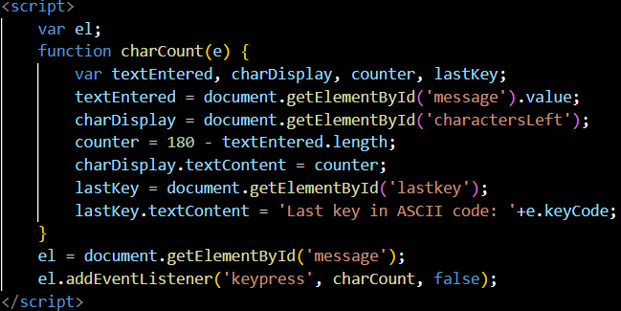

-Form events:

+Focus and blur: often used with forms or links

+Validation: Checking in JS is faster than sending data to server for it to be checked.

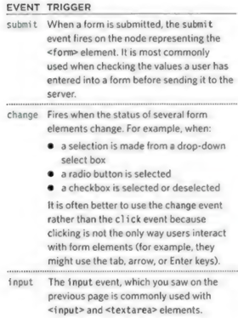

-**Mutation events & Observers**

+Whenever elements are added or removed from DOM, its structure changes. This change triggers a mutation events.

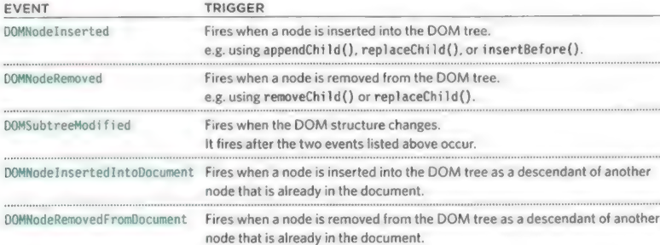

+**Caution**: Mutation event **don’t use** in **newer browsers**

+If script makes lots of changes to page, it makes page feel slow or unresponsive.

+**New mutation observers**: designed to wait until a script has finished its task before reacting, then report the changes as a batch

-**HTML5 events**

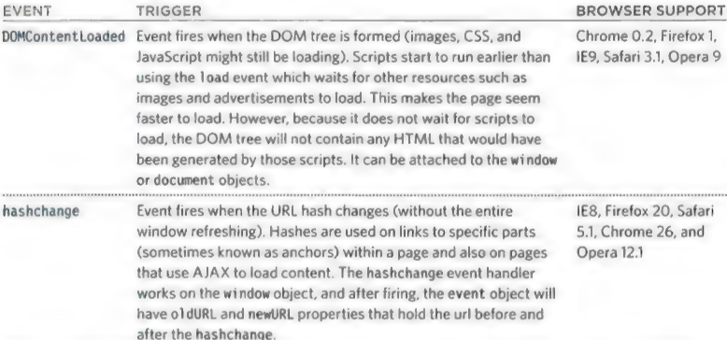

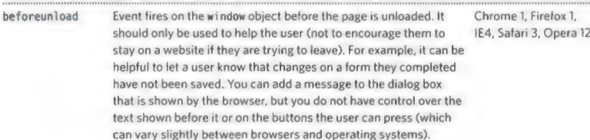

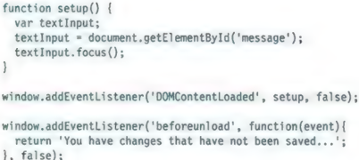

# Chapter 7: jQuery

-**jQuery**: a JS file that you include in web pages. It lets you find elements using CSS-style selectors and then do sth with elements using jQuery methods.

+Find elements using CSS-style selectors:

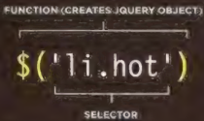

+Do sth with elements using jQuery methods:

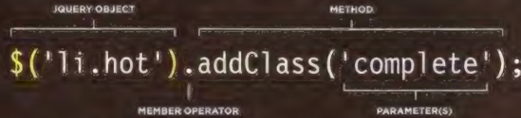

-**Where to get jQuery** and which version to use:

**+.min.js**: unnecessary spaces and carriage returns have been stripped from file. It’s done using a process **minification**

+**Use jQuery CDN**: developers.google.com/speed/libraries

+**jQuery API**: api.jquery.com

-A basic jQuery example

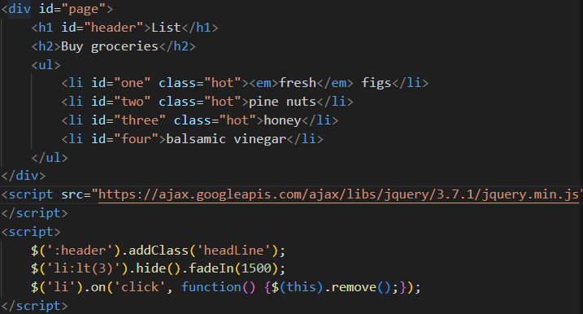

-Why use jQuery:

+Simple selectors: jQuery uses a language that is similar to front-end web developers: CSS selectors. It adds some extra CSS style selectors which offer additional functionality.

+Common tasks in less code: jQuery simplifies each of tasks (loop, add/remove elements from DOM tree, handle events, fade elements into/out of view, handle Ajax requests), allow you to write less code. jQuery offers chaining of methods.

+Cross-browser compatibility: jQuery uses feature detection to find best way to achieve a task: if browser supports the ideal way to achieve a task, it uses that approach, otherwise, it tests to see if it support the next best option to achieve the same task.

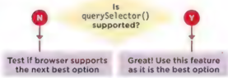

-**Finding elements**:

**+Basic selectors**:

|  |  |
| --- | --- |
| * | All elements |
| Element | All elements with that element name |
| #id | Elements whose id attribute has the value |
| .class | Elements whose class attribute has the value |
| selector1, selector2 | Elements that match more than one selector (see .add() combining selections) |

**+Hierarchy**

|  |  |
| --- | --- |
| ancestor descendant | An element that is a descendant of another element ( li a) |
| parent > child | Element that is a direct child of another element (you can use * in child to select all child elements) |
| previous + next | Adjacent sibling selector only selects elements that are immediately followed by previous element |
| previous – siblings | Sibling selector will select any elements that are a sibling of previous element |

**+Basic Filters**:

|  |  |
| --- | --- |
| :not(selector) | All elements except one in selector (div:not(‘#summary’)) |
| :first | 1st element from selection |
| :last | Last element from selection |
| :even | Elements with an even index numbers |
| :odd | Elements with an odd index numbers |
| :eq(index) | Elements with an index number equal to |
| :gt(index) | Elements with an index number greater |
| :lt(index) | Elements with index number less |
| :header | All <h1>-<h6> elements |
| :animated | Elements that are currently being animated |
| :focus | Element that currently has focus |

+Content Filters

|  |  |
| --- | --- |
| :contains(‘text’) | Element contain text as parameter |
| :empty | All elements that have no children |
| :parent | All elements have a child note (text or element) |
| :has(selector) | Contain at least one element that matches selector (div:has(p)) |

+Visibility Filters

|  |  |
| --- | --- |
| :hidden | All elements that are hidden |
| :visible | All elements that consume space in layout of page.  Not selected if: display: none;height/width:0; ancestor is hidden.  Selected if: visibility: hidden; opacity: 0 because they would tak up space in layout |

+Child Filters

|  |  |
| --- | --- |
| :nth-child(expr) | The value heir is not zero-based (eg. Ul li:nth-child(2)) |
| :first-child | 1st child from current selection |
| :last-child | Last child from current selection |
| :only-child | When there is only one child of element (div p:only-child) |

-Attribute Filters

|  |  |
| --- | --- |
| [attribute] | Elements that carry the specified attribute (with any value) |
| [attribute=’value’] | Elements that carry specified attribute with specified value |
| [attribute!=’value’] |  |
| [attribute^=’value’] | Value of attribute begins with this value |
| [attribute$=’value’] | Value of attribute ends with this value |
| [attribute*=’value’] | Value should appear somewhere in value |
| [attribute|=’value’] | Equal to given string, or starting with string and followed by a hyphen |
| [attribute~=’value’] | Value should be one of values in space separated list |
| [attribute][attribute2] | Elements that match all of selectors |

+Form

|  |  |
| --- | --- |
| :input | All input elements |
| :text | All text inputs |
| :password | All password inputs |
| :radio | All radio buttons |
| :checkbox | All checkboxes |
| :submit | All submit buttons |
| :image | All <img> elements |
| :reset | All reset buttons |
| :button | All <button> element |
| :file | All file inputs |
| :selected | All selected item from drop-down lists |
| :enabled | All enabled form elements (the default for all form elements) |
| :disabled | All disabled form elements (using CSS disabled property) |
| :checked | All checked radio buttons or checkboxes |

-**Doing things with your selection**

+When you make a selection, jQuery object created has property **length**, which return number of elements in object.

+If jQuery selection didn’t find any matching elements, you will not get an error, they won’t do or return anything

-**Content Filters**: get or change content of elements, attributes, text nodes

**+Get/Change Content**:

|  |  |
| --- | --- |
| html() | Get HTML contents of 1st element in set of matched elements or set the HTML contents of every matched element |
| text() | Get the combined text contents of each element in set of matched elements, including their descendants, or set the text contents of matched elements |
| replaceWith() | Replace each element in the set of matched elements with the provided new content and return the set of elements that was removed. |
| remove() | Remove the set of matched elements from the DOM. |

**+Elements**:

|  |  |
| --- | --- |
| before() | Insert content, specified by parameter, before each element in the set of matched elements |
| after() | Insert content, specified by parameter, after each element in set of matched elements |
| prepend() | Insert content, specified by the parameter, to the beginning of each element in the set of matched elements. |
| append() | Insert content, specified by the parameter, to the end of each element in the set of matched elements. |
| remove() |  |
| clone() | Create a deep copy of the set of matched elements. |
| unwrap() | Remove the parents of the set of matched elements from the DOM, leaving the matched elements in their place. |
| detach() | Remove the set of matched elements from the DOM. |
| empty() | Remove all child nodes of the set of matched elements from the DOM |
| add() | Create a new jQuery object with elements added to the set of matched elements. |

+**Attributes**

|  |  |
| --- | --- |
| attr() | Get the value of an attribute for the first element in the set of matched elements or set one or more attributes for every matched element. |
| removeAttr() | Remove an attribute from each element in the set of matched elements. |
| addClass() | Adds the specified class(es) to each element in the set of matched elements |
| removeClass() | Remove a single class, multiple classes, or all classes from each element in the set of matched elements |
| css() | Get the value of a computed style property for the first element in the set of matched elements or set one or more CSS properties for every matched element. |

**+Form values**:,

|  |  |
| --- | --- |
| val() | Get the current value of the first element in the set of matched elements or set the value of every matched element. |
| isNumeric() | Determines whether its argument represents a JavaScript number |

-**Finding Elements**: Find an select elements to work with & traverse DOM

**+General**

|  |  |
| --- | --- |
| find() | Get the descendants of each element in the current set of matched elements, filtered by a selector, jQuery object, or element |
| closest() | For each element in the set, get the first element that matches the selector by testing the element itself and traversing up through its ancestors in the DOM tree. |
| parent() | Get the parent of each element in the current set of matched elements, optionally filtered by a selector |
| children() | Get the children of each element in the set of matched elements, optionally filtered by a selector. |
| siblings() | Get the siblings of each element in the set of matched elements, optionally filtered by a selector |
| next() | Get the immediately following sibling of each element in the set of matched elements. If a selector is provided, it retrieves the next sibling only if it matches that selector. |
| nextAll() | Get all following siblings of each element in the set of matched elements, optionally filtered by a selector. |
| prev() | Get the immediately preceding sibling of each element in the set of matched elements. If a selector is provided, it retrieves the previous sibling only if it matches that selector. |
| prevAll() | Get all preceding siblings of each element in the set of matched elements, optionally filtered by a selector, in the reverse document order. |

+**Filter/Test**:

|  |  |
| --- | --- |
| filter() | Reduce the set of matched elements to those that match the selector or pass the function’s test. |
| not() | Remove elements from the set of matched elements. |
| has() | Reduce the set of matched elements to those that have a descendant that matches the selector or DOM element. |
| is() | Check the current matched set of elements against a selector, element, or jQuery object and return true if at least one of these elements matches the given arguments. |
| contains() | Select all elements that contain the specified text. |

+**Order in selection**:

|  |  |
| --- | --- |
| .eq() | Reduce the set of matched elements to the one at the specified index. |
| :lt() | Select all elements at an index less than index within the matched set. |
| :gt() | Select all elements at an index greater than index within the matched set. |

-**Dimension/Position**: get or update the dimensions or position of a box

**+Dimension**

|  |  |
| --- | --- |
| height() | Get the current computed height for the first element in the set of matched elements or set the height of every matched element. |
| width() | Get the current computed width for the first element in the set of matched elements or set the width of every matched element. |
| innerHeight() | Get the current computed inner height (including padding but not border) for the first element in the set of matched elements or set the inner height of every matched element. |
| innerWidth() | Get the current computed inner width (including padding but not border) for the first element in the set of matched elements or set the inner width of every matched element. |
| outerHeight() | Get the current computed outer height (including padding, border, and optionally margin) for the first element in the set of matched elements or set the outer height of every matched element. |
| outerWidth() | Get the current computed outer width (including padding, border, and optionally margin) for the first element in the set of matched elements or set the outer width of every matched element. |
| $(document).height() |  |
| $(document).width() |  |
| $(window).height() |  |
| $(window).width() |  |

+**Position**:

|  |  |
| --- | --- |
| offset() | Get the current coordinates of the first element, or set the coordinates of every element, in the set of matched elements, relative to the document. |
| position() | Get the current coordinates of the first element in the set of matched elements, relative to the offset parent. |
| scrollLeft() | Get the current horizontal position of the scroll bar for the first element in the set of matched elements or set the horizontal position of the scroll bar for every matched element |
| scrollTop() | Get the current vertical position of the scroll bar for the first element in the set of matched elements or set the vertical position of the scroll bar for every matched element. |

-**Effects & Animations**: add effects and animation to parts of the page

**+Basic**:

|  |  |
| --- | --- |
| show() | Display the matched elements. |
| hide() | Hide the matched elements. |
| toggle() | Display or hide the matched elements. |

**+Fading**:

|  |  |
| --- | --- |
| fadeIn() | Display the matched elements by fading them to opaque. |
| fadeOut() | Hide the matched elements by fading them to transparent. |
| fadeTo() | Adjust the opacity of the matched elements. |
| fadeToggle() | Display or hide the matched elements by animating their opacity. |

+**Sliding**:

|  |  |
| --- | --- |
| slideDown() | Display the matched elements with a sliding motion. |
| slideUp() | Hide the matched elements with a sliding motion. |
| slideToggle() | Display or hide the matched elements with a sliding motion. |

**+Custom**:

|  |  |
| --- | --- |
| delay() | Set a timer to delay execution of subsequent items in the queue. |
| stop() | Stop the currently-running animation on the matched elements. |
| animate() | Perform a custom animation of a set of CSS properties. |

-**Events**: create event listeners for each element in the selection

**+Document/File**:,

|  |  |
| --- | --- |
| ready() | Specify a function to execute when the DOM is fully loaded. |
| load() | Load data from the server and place the returned HTML into the matched elements. |

+**User Interaction**:

|  |  |
| --- | --- |
| on() | Attach an event handler function for one or more events to the selected elements. |

-**A matched set/jQuery Selection**: When you select one or more elements, a jQuery object is returned. It’s known as a matched set/jquery selection

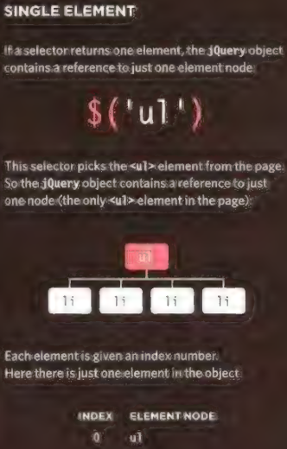 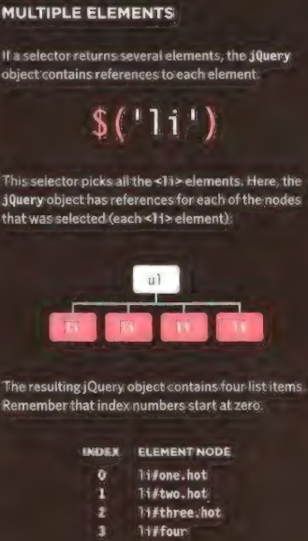

-**jQuery methods that get and set data**

+**Get information**: html() get information form an element, it will return the content of the 1st element in matched set

+**Set information**: html(text): replace the content of each element in matched set.

-**jQuery objects store references to elements**

+When you create a selection with jQuery, it stores a reference to the corresponding nodes in DOM tree. It doesn’t create copies of them.

+jQuery object is an array-like object because it stores a list of elements in the same order that they appear in HTML document

-**Caching jQuery selections in variables**

+A jQuery object stores references to elements. Caching a jQuery object stores a reference to it in a variable.

-**Looping**

+With jQuery, when a selector returns multiple elements, you can update all of them using one method. There is no need to use a loop.

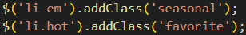

+The ability to update all of elements in jQuery selection is **implicit iteration**

-Chaining

+chaining: the process of placing several methods in the same selector.



+Most methods used to update jQuery selection can be chained. The methods that retrieve information from DOM can’t be chained.

-**Checking a page is ready to work with**:

+**ready()**: check that the page is ready for your code to work with

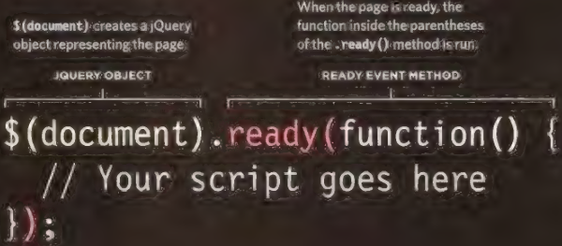

+**Shorthand**: create function-level scope for its variables. This scope prevents naming collisions.

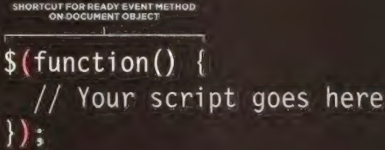

-Getting element content:

+html()

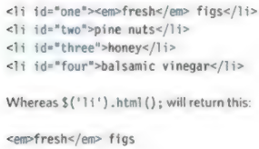

+text()

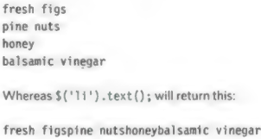

-**Update elements**

+Using a function to update content:

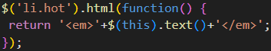

+this refers to current list item.

-**Changing content**:

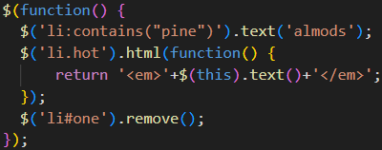

-**Insert elements**:

+Create new elements in a jQuery object:



+Add the new elements to the page: before(), after(), prepend(), append()

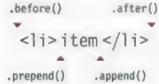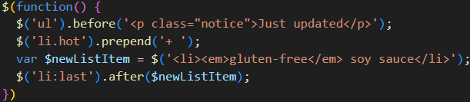

-**Get and set attribute values**: attr(), removeAttr(), addClass(), removeClass()

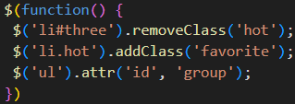

-**Get and set CSS properties**

+Get CSS property: 

+Set CSS property:



Increase and decrease values with dimensions in pixels



+Set multiple properties:

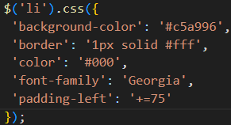

-**Work with each element in a selection**

+each() and $(this)

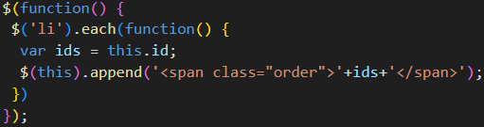

-Event methods:

+on(): handle all events

+jQuery events:

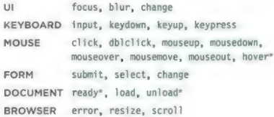

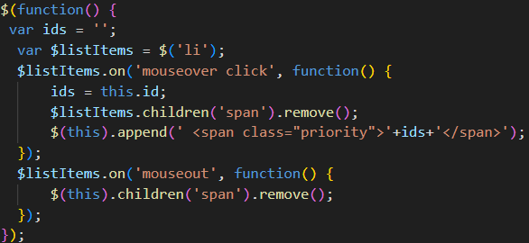

-Event Object:

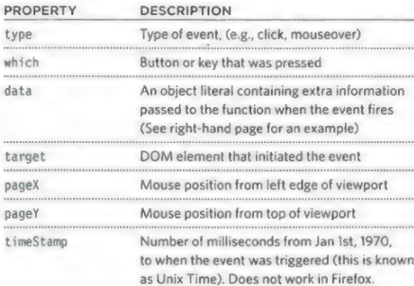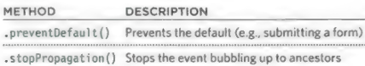

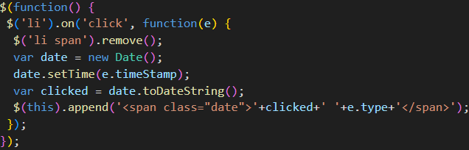-**Additional Parameters for Event Handlers**

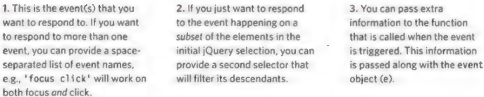

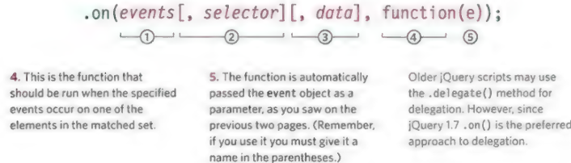

-**Delegating Events**

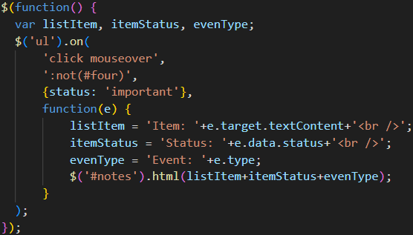

-Effect

+**Basic Effects**:

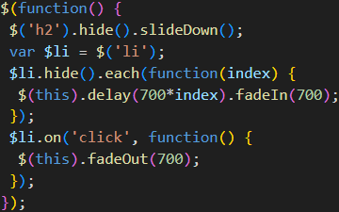

+Animating CSS Properties: animate() create your own effects and animations by changing CSS properties

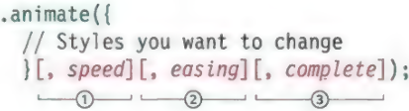

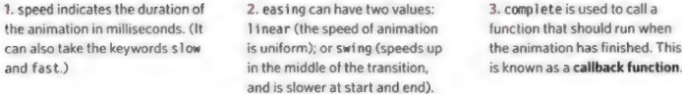

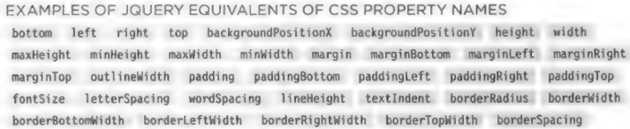

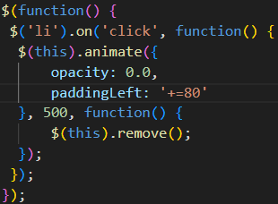

**-Traverse:**

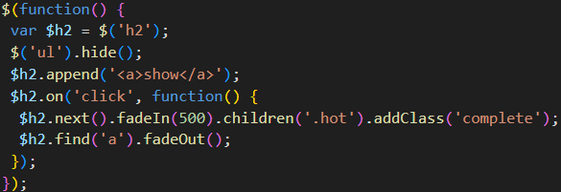

-**Add & Filter Elements in a Selection**

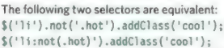

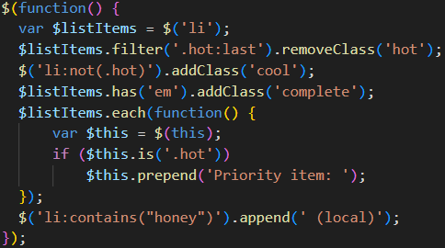

**-Find Items by Order**

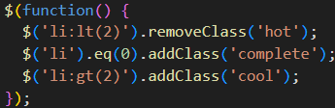

-**Select Form Elements**

+Retrieve value of elements: .val(), .filter(), .is(), $.isNumeric()

+Events:

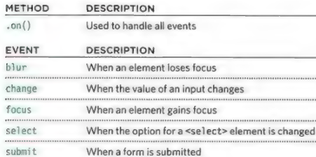

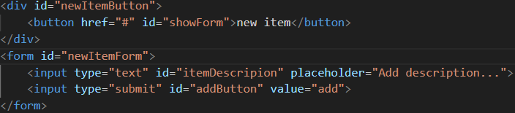

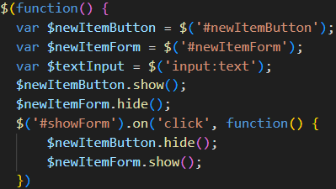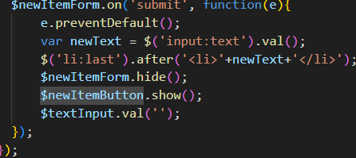

-**Cut & Copy Elements**

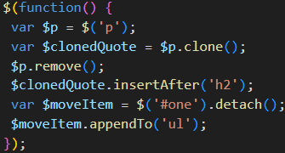

-Box dimension:

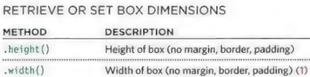

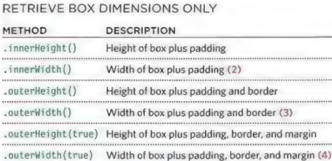

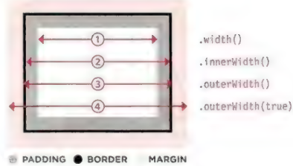

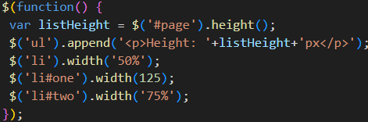

-**Windows & Page Dimensions**

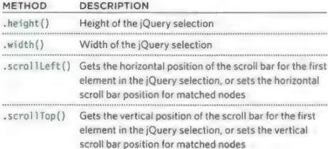

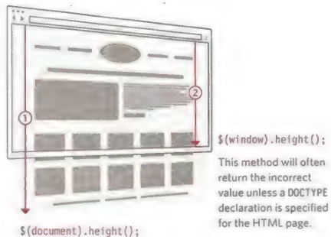

**-Position of Elements on the page**

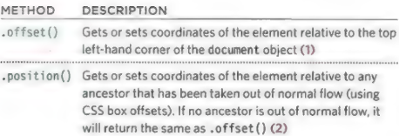

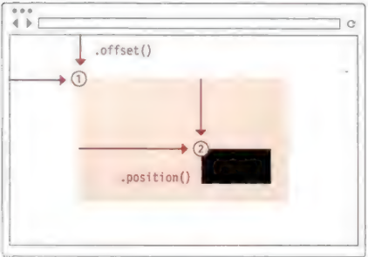

+Each of them returns an object that has 2 properties: top and left.

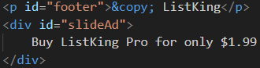

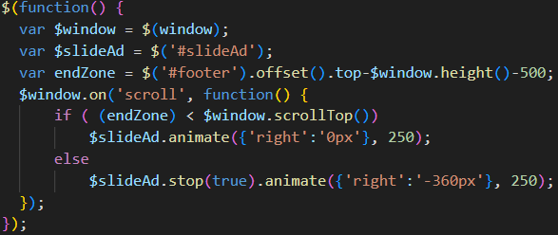

+Calculate the end zone:

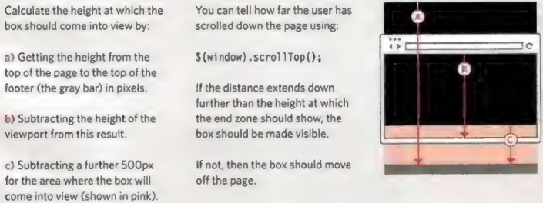

-Ways to include jQuery in page:

+CDN (Content Delivery Network) is a series of servers spread out around the world. They are designed to server static files very quickly. CDN tries to find a server near you, then sends files from that server so data doesn’t travel as far. With jQuery, users might have already downloaded and cached file from CDN when visiting another site.

+Load jQuery from a CDN

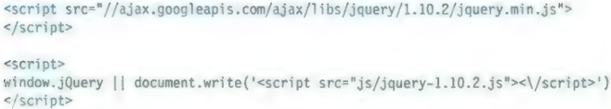

-Where to place your scripts

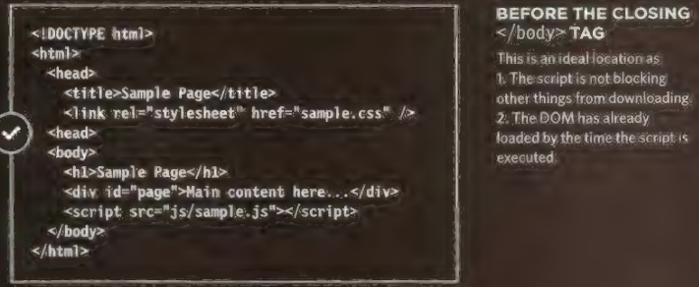

-jQuery Documentation: api.jquery.com

**-Extend jQuery with Plugins**

+Plugins: scripts that extend the functionality of jQuery library: plugins. jquery.com

**-JS Libraries**

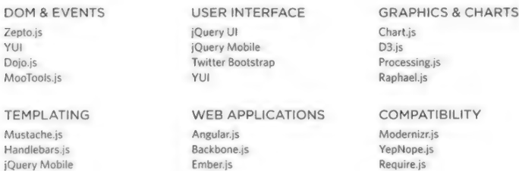

-Prevent conflicts with other libraries

+$() was shorthand for jQuery(). $ symbol is used by other libraries (prototype.js, MooTools, YUI). To avoid conflicts with those scripts, use these techniques

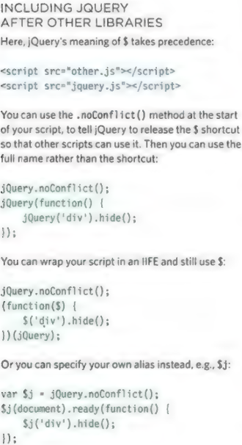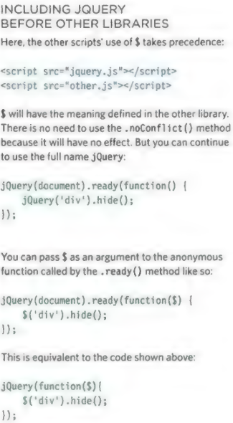

# Chapter 8: Ajax & JSON

# Chapter 9: APIs